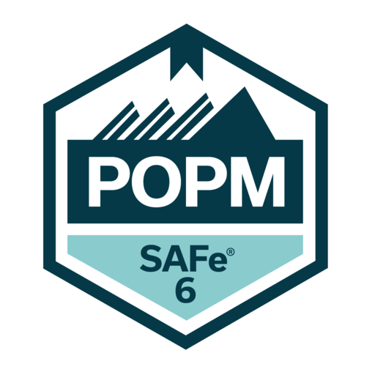
Owner/Product Manager Certification Course

Course Overview
This course provides a comprehensive understanding of how Product Owners and Product Managers operate within a SAFe environment. It focuses on helping participants define, prioritize, and manage product backlogs while aligning product strategy and execution across agile teams and the broader Agile Release Train (ART).
Participants will learn how to support value delivery at scale, connect customer needs to agile execution, and contribute effectively to Program Increment (PI) Planning, forecasting, and product delivery in enterprise environments.

Learning Objectives
- Understand the roles and responsibilities of Product Owners and Product Managers in SAFe environments
- Define, prioritize, and manage product backlogs effectively
- Lead and support Program Increment (PI) Planning
- Align product vision and roadmaps with business goals
- Manage forecasting, risks, and dependencies across teams
- Apply lean-agile thinking and customer-centricity to product delivery
- Create and refine features and stories for rapid delivery
- Work effectively with agile teams and the Agile Release Train (ART)
- Support value delivery across the enterprise
- Apply AI skills in backlog refinement, prioritization, feature discovery, and customer connection using responsible practices

Course Modules
1. Introduction to Product Ownership and Product Management in SAFe
Explores how Product Owners and Product Managers contribute to product strategy and execution in SAFe organizations.
2. Roles and Responsibilities
Covers the day-to-day responsibilities of Product Owners and Product Managers, including backlog ownership, forecasting, and managing risks and dependencies.

3. SAFe Framework Overview
Introduces the SAFe structure, agile teams, Agile Release Trains (ARTs), and the role of product leadership in enterprise delivery.
4. Product Backlog Ownership and Prioritization
Focuses on managing and prioritizing backlog items to support business goals and customer value.
5. Product Vision and Roadmaps
Explains how to align product direction, vision, and roadmaps with enterprise strategy and execution.
6. Lead and Support PI Planning
Covers preparation for PI Planning, collaboration with teams, and establishing clear PI objectives.
7. Forecasting, Risks, and Dependencies
Introduces practical approaches for anticipating risks, managing dependencies, and improving delivery confidence.
8. Agile Product Delivery
Explains how to use lean-agile thinking and customer-centricity to define, prioritize, and deliver features and stories that can be built, tested, and released quickly.
9. Working with Agile Teams and the ART
Focuses on collaboration with agile teams and participation in the broader system of delivery across the ART.

10. Practical Application and Team Engagement
Covers real-world exercises, group discussions, and product work that connects course concepts to day-to-day responsibilities.
11. AI Skills for Modern Product Roles
Introduces practical techniques for applying AI in backlog refinement, prioritization, feature discovery, and customer connection using responsible AI practices.
12. Value Delivery at Scale
Explains how Product Owners and Product Managers help connect customer needs, team execution, and enterprise strategy to support consistent value delivery.

Target Audience
- Product Owners
- Product Managers
- Project Managers
- Scrum Masters
- Business Analysts
Program Managers
Prerequisites
There are no formal prerequisites. This course is presented as a foundational-level course for individuals who are new to SAFe or growing into product-focused roles.

Certification Alignment
This course prepares participants for the SAFe Product Owner/Product Manager (POPM) certification. After completing the course, participants are eligible to take the exam. Passing the exam earns the SAFe Product Owner/Product Manager certification and a digital badge. The certification process includes access to the course workbook and online learning platform, an unlimited-attempt practice test, customer support, and a timed multiple-choice 45-question exam.

Key Benefits
- Learn how Product Owners and Product Managers fit into the SAFe system of delivery
- Build practical skills in backlog ownership, prioritization, forecasting, and dependency management
- Strengthen your ability to lead and support PI Planning
- Improve product delivery using lean-agile thinking and customer-centricity
- Gain practical experience through exercises, discussions, and hands-on product work

